Pumpkin Smash
Do not bin your pumpkin, let us compost
it to help grow food
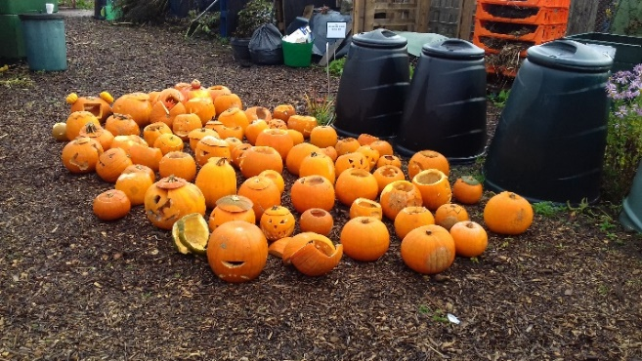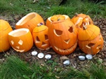
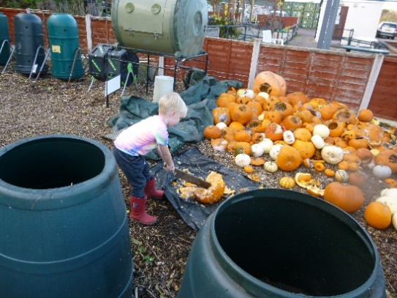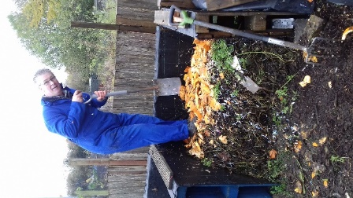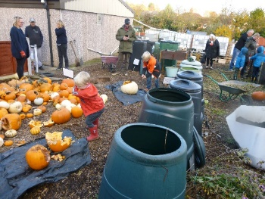
D
Saturday 12th November 10.30 - 12.30
(continuing as required)
Stokes Wood Allotments 2B Stokes Drive Leicester LE3 9BS
Refreshments available

Schools, Clubs, Groups, Families & Individuals
Bring your own, and your friends, pumpkins or smash ours.

To donate your pumpkins or arrange a group Smash on another day email: carryoncomposting1@gmail.com

