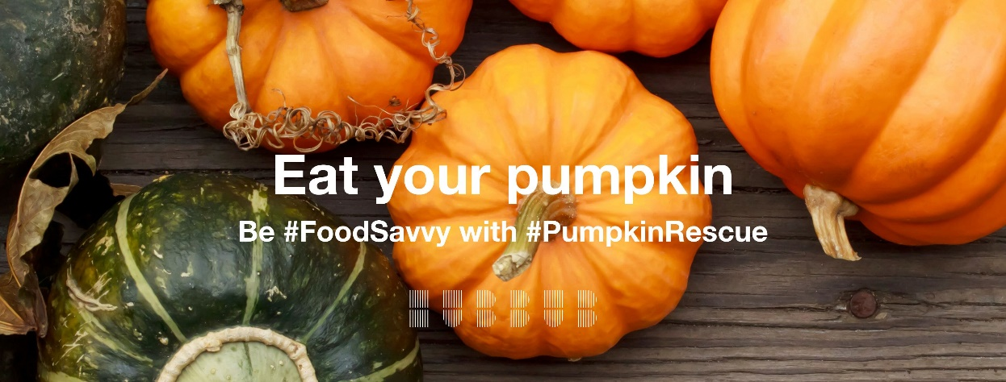
Halloween need not be the Festival of Food waste
Selected restaurants and pubs are invited to join our efforts to help reduce waste at Halloween by taking part in our Leicester and Leicestershire Pumpkin Rescue events by offering pumpkin based dishes and menus. You are the only pub in the Coalville area being invited to take part as any pub that makes pies as good as yours should produce really good pumpkin pie.
It is estimated that in the UK up to four million pumpkins are brought to carve and display over Halloween with the edible flesh of these pumpkins being discarded as waste and ending up with most of the lanterns in landfill. This produces an additional 18,000 tons of landfill waste directly attributable to the Halloween festivities. This, according to the environmental charity Hubbub, is equivalent to 360 million portions of pumpkin pie.
Much of this waste is due to people being unaware of the versatility of pumpkin flesh as a food or not realising that the flesh discarded when carving the pumpkin can be eaten. It is calculated that in the UK only 33% cook the fresh of the pumpkins they carve out. On this basis, farmers are growing acres of food just for it to be thrown away
Join us in reducing pumpkin waste while celebrating Halloween
- Provide pumpkin recipes, meals and cooking advice
- Organise a carved pumpkin event and photograph the pumpkins and carvers in your Community Centre or school before displaying them to Stokes Wood Allotment, 2B Stokes Drive, Leicester, LE3 9BS
- Encourage carvers to cook the flesh from the pumpkins
- Book a place on the Pumpkin Lunch at Stokes wood and bring a pumpkin dish to share
- Enter and attend the Best Carved pumpkin judging at Stokes Wood Allotment
- Join the Pumpkin Smash at Stokes Wood Allotment Compost Demonstration Site smashing of the carved pumpkins and start composting them
If you are interested in helping to organise, host or support one or more of these events, please contact:
Carryoncomposting1@gmail.com www.carryoncomposting.com

